Model Accuracy during training:
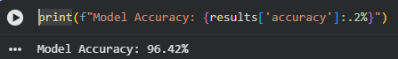

Model Performance Evaluation:
